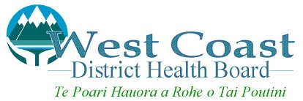 | Complaint Form

Name of Person Making Complaint
Address
Phone Number

1 | Are you making a complaint on behalf of someone else? | Yes |  | No

If your answer is Yes, please state the person’s name, address and your relationship to that person, in the spaces below. You will also need to get that person to sign this Form as well. (NOTE: The WCDHB requires that any person involved in a complaint is aware of the complaint and consents to the WCDHB investigating the complaint)

Name (of person involved in the complaint)
Address
Your relationship to this person

Signed: |  | Date:

THE COMPLAINT

Date Of Event
Location
Person(s) Involved

Please state main aspects of complaint

(Please attach a separate sheet and continue if necessary)

Please state what would be an acceptable outcome for the complaint

(STAFF NOTE: for complaints taken over the telephone, please read this section out to the person making the complaint:

I understand and agree that information relating to this complaint may be released to the persons involved with the complaint, and to the WCDHB Management Committee to ensure that the investigation is fair and impartial to all parties concerned.

Please note that WCDHB’s complaints management process adheres to the requirements of the Code of Health and Disability Services Consumers Rights and the Health Information Privacy Code.

Signed: |  | Date:

Please return this completed form to:

The Office Of The Chief Executive Officer
West Coast District Health Board.
PO Box 387
GREYMOUTH

